- In your confirmation email, select “ set up account now “
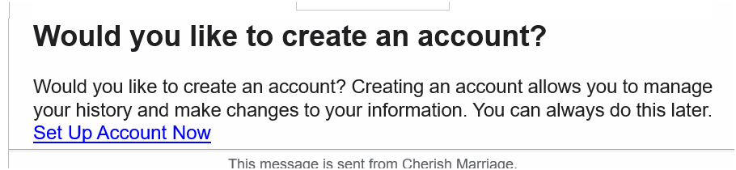

- In browser, Select “Claim my account”
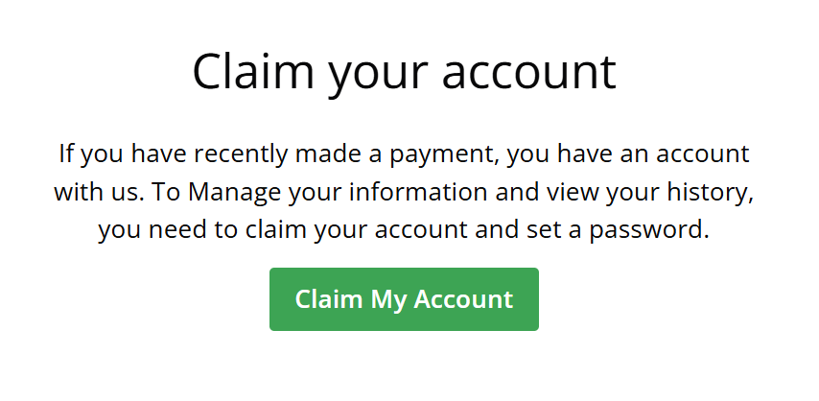

- Your Email will automatically appear, select “send me the link”
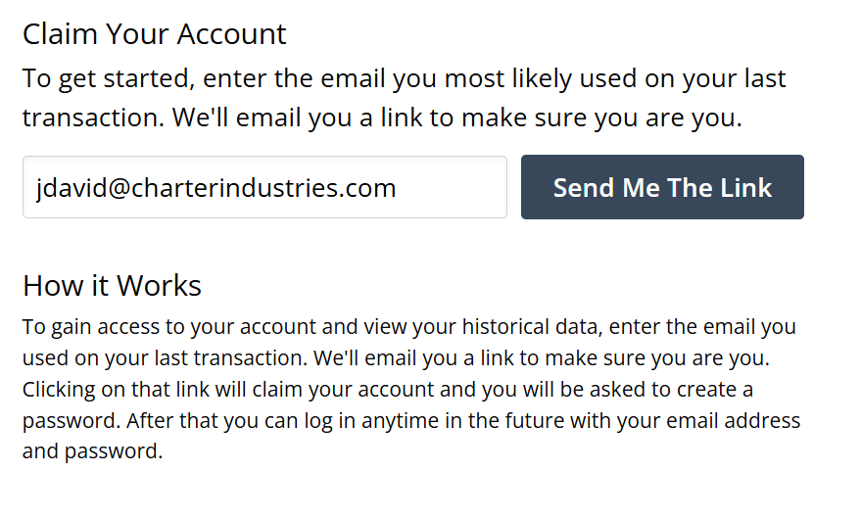

- In your email, Select “activate account” or select see in browser
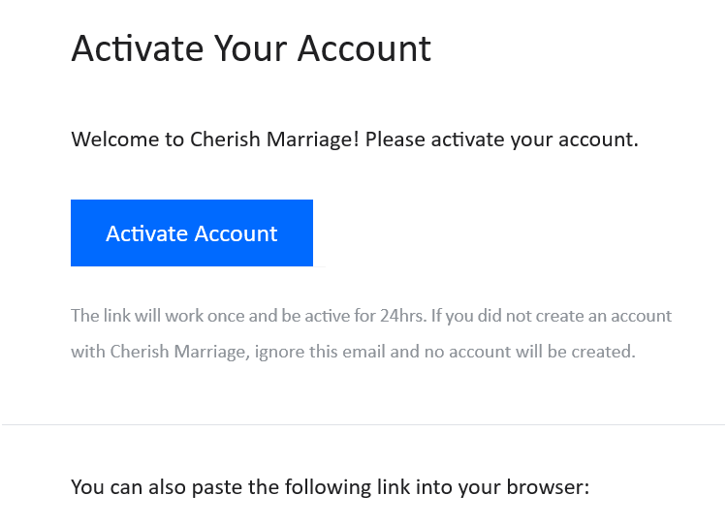

- In browser, create a password for your account
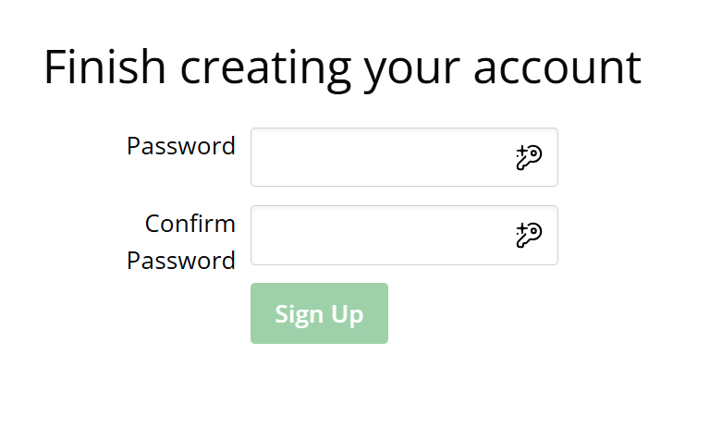

- In your browser, select “tickets”
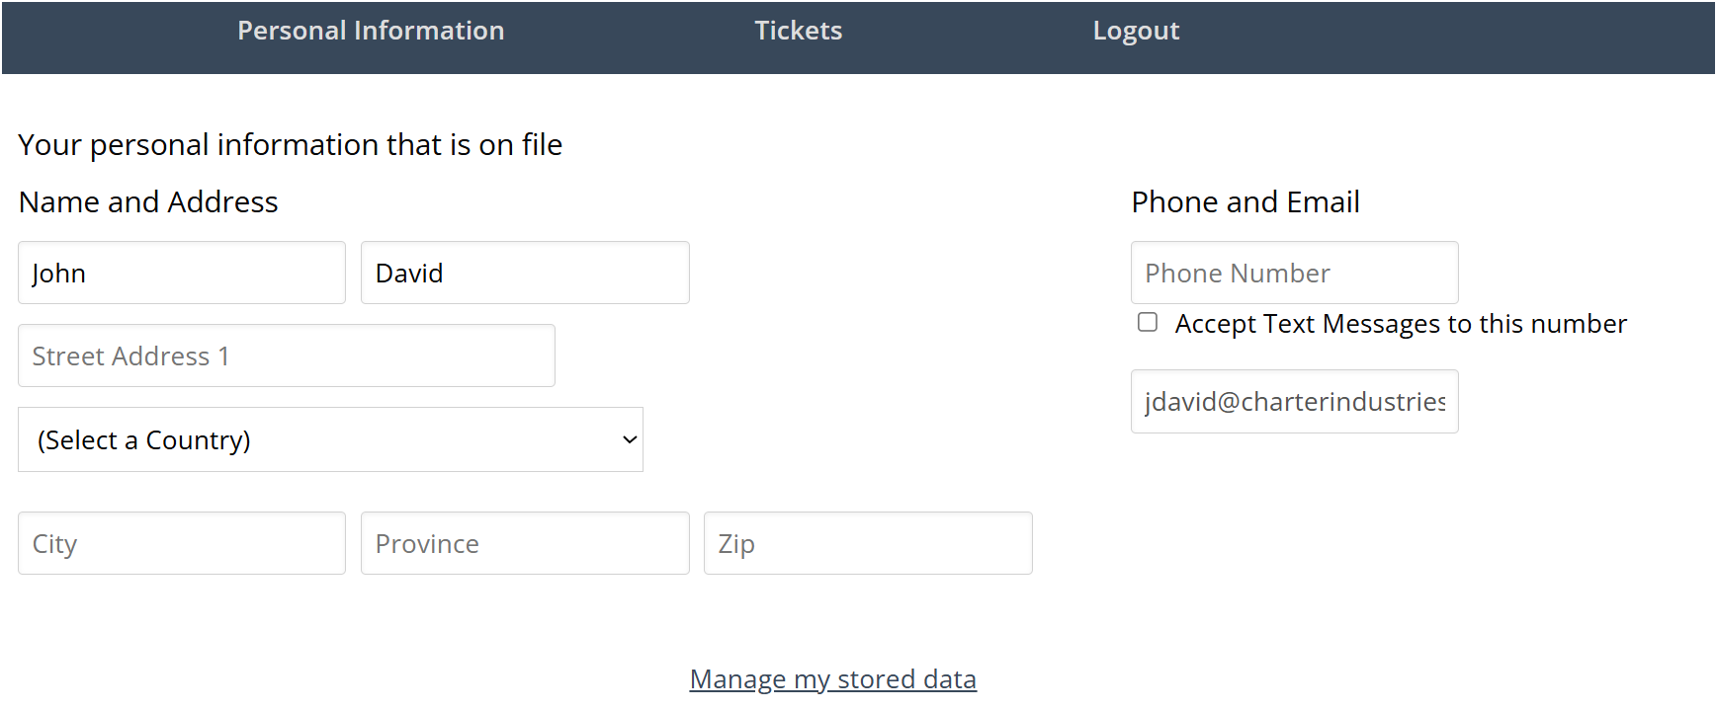

- In browser, select “ Cherish Marriage “
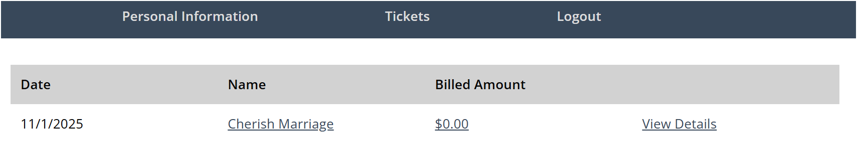

- In browser, select “edit”
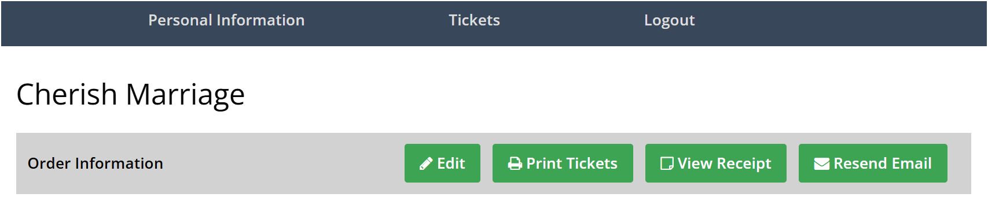

- Update your ticket information as needed.

